ASG -AIRLINES

Introduction
This project is about analysing flight data and preparing it for reporting. The original data is in an Excel workbook and contains information about flights, bookings, passengers and payments. Python and Pandas are used to read, clean and process the data. The final data is used in Power BI to make a dashboard.
Objective of the Project
- Understand the given flight dataset.
- Clean the raw data and handle common data problems.
- Calculate flight duration correctly.
- Identify overnight flights.
- Find and flag data quality problems.
- Prepare cleaned data for Power BI.
- Create useful flight operation KPIs and charts.
Dataset Description
The project mainly works with four types of data:
Dataset | Description
Flights | Flight details such as flight ID, airline, source, destination and departure/arrival information.
Bookings | Information related to flight bookings.
Passengers | Passenger-related information.
Payments | Payment and booking transaction information.

Project Workflow
The basic flow of the project is:
Excel → Python → Cleaning → Transformation → Validation → Cleaned Data → Power BI
First, the Excel workbook is read using Python. The data is cleaned and checked. New fields such as flight duration, route and overnight status are created. The processed data is saved as CSV files and prepared for Power BI.
System Architecture
The architecture is simple. The Excel file is the input, Python is used for processing, processed data is stored as files, and Power BI is used for the final dashboard.
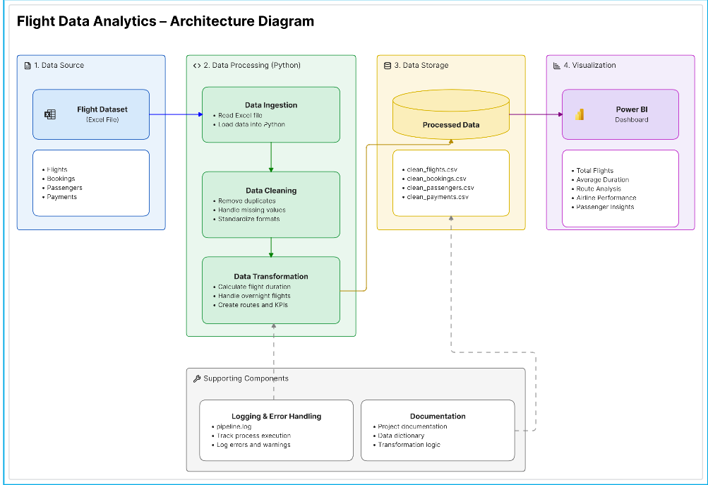
Data Flow Diagram
The data first comes from the Excel file. It is cleaned and transformed in Python. After validation, the final data is stored and used in Power BI.
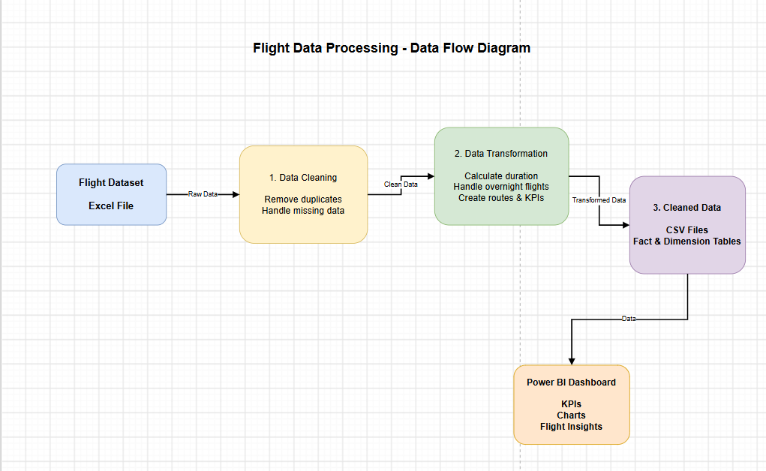
Data Cleaning
- Removed exact duplicate records.
- Removed unnecessary spaces from text values.
- Checked missing values.
- Checked Flight IDs for valid patterns.
- Checked airport codes and standardised values where needed.
- Investigated repeated Flight IDs instead of automatically deleting them.
- Flagged suspicious records for checking.
Data Transformation
- Flight Duration
Flight duration is calculated by taking the difference between the arrival timestamp and departure timestamp. The result is stored in minutes. Source duration can also be compared with the calculated value to find unusual differences.
- Overnight Flights
Some flights arrive after midnight. The project compares the departure and arrival dates. If the arrival date is later than the departure date, the flight is marked as an overnight flight.
- Other Transformations
- Route creation
- Departure date and date parts
- Airline information
- KPI fields
- Anomaly flags
Data Validation
Check | Purpose
Missing values | Find important fields that are empty
Flight ID validation | Find invalid identifiers
Duplicate Flight IDs | Check repeated flight records
Timestamp check | Find incorrect departure/arrival order
Duration check | Find negative or unusual durations
Referential integrity | Check links between related tables
Anomaly checks | Identify records that may have problems

Anomaly Handling
The project does not simply delete every record with a problem. Instead, flags are used to identify possible data-quality issues so that the records can be reviewed later.
Issue | Action
Invalid Flight ID | Flagged
Duplicate Flight ID | Checked
Negative duration | Flagged
Timestamp problem | Flagged
Duration difference | Checked against source value

Data Model
The processed data is arranged into fact and dimension tables for Power BI. Fact tables contain the main activity records and dimension tables provide supporting information.
Power BI Dashboard
The processed data is used in Power BI to create the final dashboard. The main purpose is to give a quick view of flight operations and data quality.
- Total Flights
- Average Flight Duration
- Airline Distribution
- Route Traffic
- Flight Trends
- Anomaly / Data Quality information

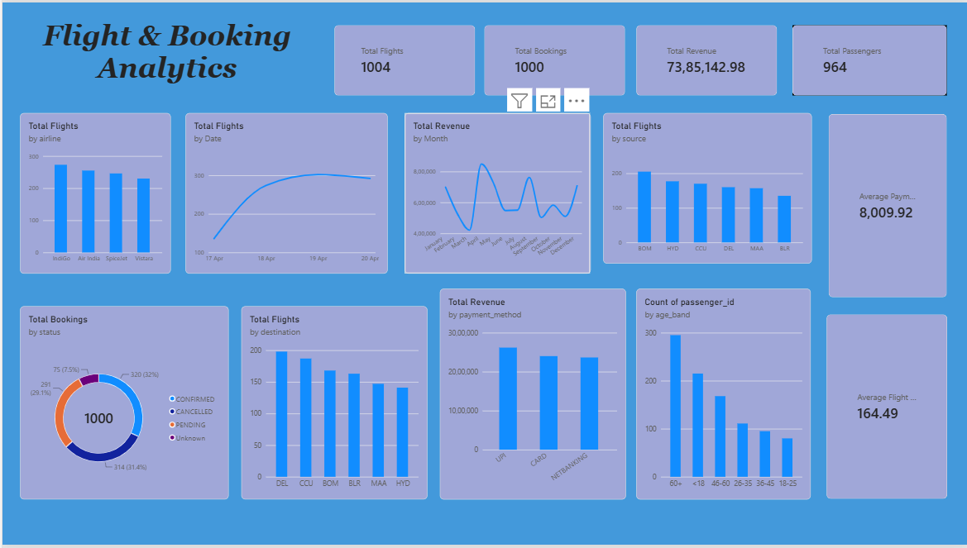

Error Handling and Logging
Basic error handling is included in the Python pipeline. Problems during reading or processing can be handled using exception handling. A log file is also used to keep track of pipeline execution and processing issues.
The project includes a pipeline log file: Neo Stats/logs/pipeline.log
Scalability
The current project uses Python and Pandas because the supplied dataset is manageable on a normal computer. If the amount of data becomes much larger, the same type of processing can be moved to PySpark, Azure Databricks or Microsoft Fabric.
Conclusion
Overall, this project shows how raw flight data can be cleaned and converted into useful information. Python and Pandas were used for data processing, including cleaning, validation, flight duration calculation and overnight flight handling. The processed data was then prepared for Power BI so the flight information can be viewed using charts and KPIs.

